**Web Design and Development Foundations with HTML5**

**Hands-On Practice (HOP)**

HOP 6.1

box1.html

box2.html

HOP 6.2

HOP 6.3

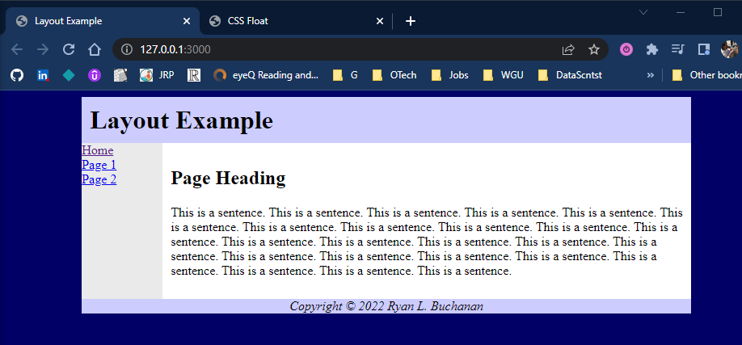

HOP 6.4

HOP 6.5

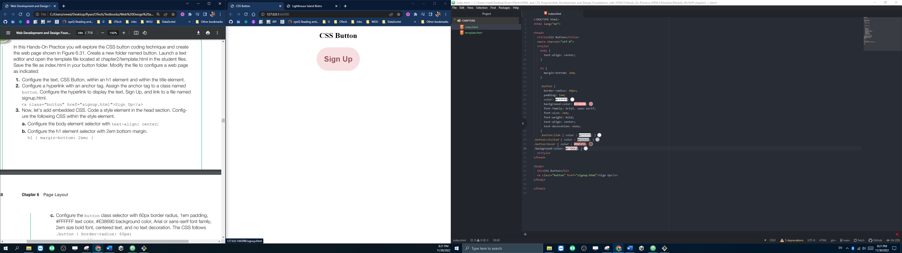

HOP 6.6

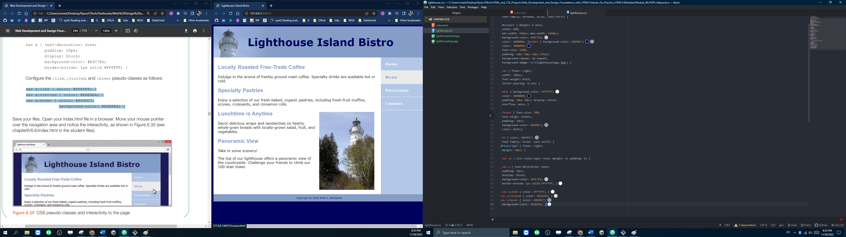

HOP 6.7

HOP 6.8

Next to each other

On top of each other

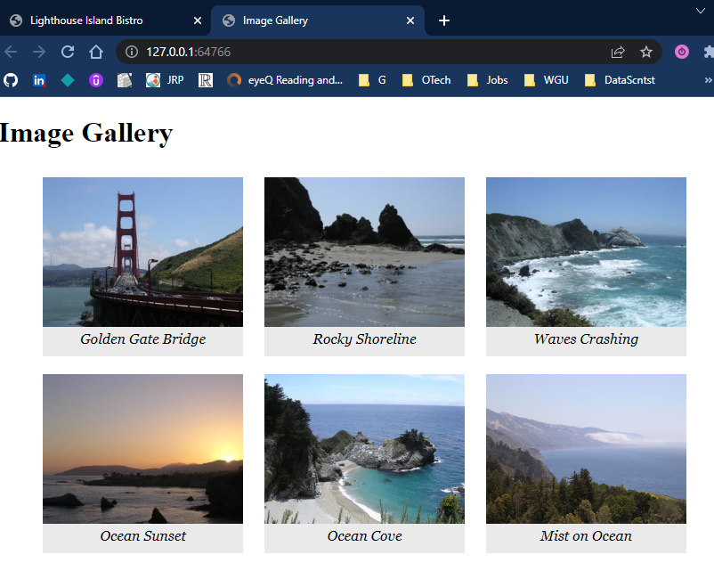

HOP 6.9

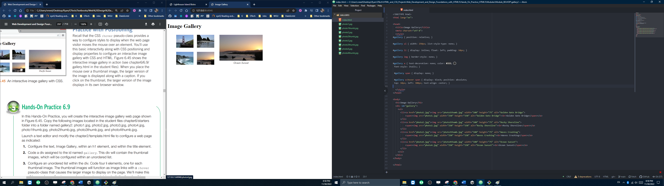

HOP 6.10

HOP 6.11

ch6block zipped